City of Albion
City Council Meeting
April 17, 2017

- Call To Order

Mayor Brown opened the regular session at 7:00 p.m.

- Moment of Silence To Be Observed

- Pledge of Allegiance

- Roll Call

PRESENT: Maurice Barnes (1), Lenn Reid (2), Sonya Brown (3), Marcola Lawler (4) Jeanette Spicer (5), Andrew French (6) and Mayor Brown.

Staff Present: Sheryl Mitchell, City Manager; Cullen Harkness, City Attorney; Stacey Levin, Assistant City Manager; Jill Domingo, City Clerk; Scott Kipp, Chief Public Safety and John Tracy, Director Planning, Building & Code Enforcement.

- Mayor & Council Member’s Comments

Comments were received from Council Members Lawler and Spicer.

VI. Presentations

- Update on Comprehensive Plan and RRC-Danielle Nelson

Danielle Nelson updated the Mayor and Council on the Comprehensive Plan and the Redevelopment Ready Community with the following information:

- Business Growth and Development:
- Albion EDC Strategic Direction
- Albion EDC small business & entrepreneurial workshops
- Free 1-on-1 counseling for businesses through Albion EDC partnership with SBDC
- Delivering Municipal Services:
- Capital Improvements Plan-COMPLETED
- Stabilizing Downtown:
- Several for-profit developments
- Bohm Theatre expansion
- Commercial Business Development Process identified by Albion EDC
- Strong K-12 Education System:
- Marshall Public Schools established a Community Advisor Committee
- Early College Program offered through MPS and KCC
- Improving Transportation:
- City Manager has upcoming meeting with MDOT to identify funding options for a public transit system
- 2017 MDNR Trust Fund Grant Submitted
- Superior Street construction has begun
- Corridor Improvements:
- Eaton and Austin Corridors identified as a project by Albion EDC
- MDOT Summer Youth Program
- MDNR Trust Fund Grant (if accepted) will improve Austin Avenue non-motorized transit options
- Community Health:
- Planning Commission approved five (5) community garden applications
- Rural Health grant application submitted to bring Urgent Care Center to Albion

Comments were received from Council Members Brown and Lawler and Mayor Brown.

B. Run Albion-Bill Dobbins

Bill Dobbins updated the Mayor and Council on the Run Albion races with the following information:

- Three (3) Events/Races all being held in Albion.
- Run the Rock-May 5th, 2017
- History Hustle-July 14th, 2017
- Forks 5K/10K-September 15th, 2017
- Each event includes 5K, 10K and Fun Run
- All events are open to runners and walkers of ALL abilities
- Goals:
- Create events that bring individuals and families to Albion
- Highlight features of Albion-parks, waterways, college and downtown
- Fundraiser for community organizations
- Promote health and wellness in the community
Race Management-
- 3 Disciplines Racing will manage the series which will be three (3) events each year for the next three (3) years
- Manage events across the US
- All types of events-5Ks, marathons, triathlons
- Over 15 years of experience
- 3 year commitment to managing the series

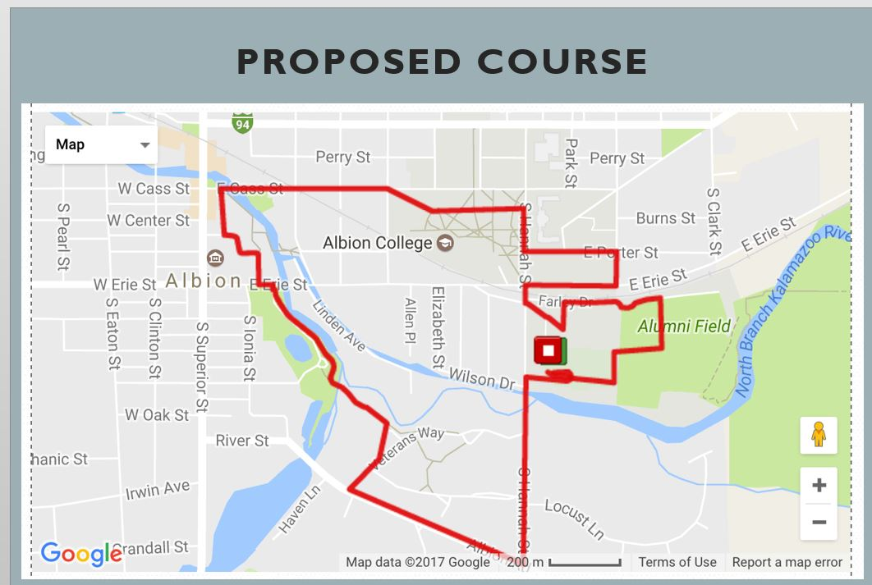

- Course:
- Orange cones, flags, painted markings and staff at every course turn
- Minimal vehicular stoppage-all above at intersections to warn motorists
- Fund Raising:
- Albion Forks Senior Center-1st Race
- Albion Historical Society-2nd Race
- Little Lambs of Jesus-3rd Race
- Sponsors:
- Caster Concepts
- Team One Plastics
- Homestead Savings Bank
- Registration:
- www.albion5k.com

Comments were received from Council Members French and Spicer and City Manager Mitchell.

VII. Public Comments (Persons addressing the City Council shall limit their comments to agenda items only and to no more than three (3) minutes. Proper decorum is required.)

No comments were received.

- Consent Calendar (VV)

- Approval Regular Session Minutes – April 3, 2017
- Approval Study Session Minutes-April 4, 2017

Council Member Brown asked for a correction to the April 3, 2017 Regular Session Minutes as follows:

Item O-Future Agenda Items should read Council Member Barnes asked for an update from the EDC regarding the redevelopment of the former Albion Malleable/Harvard site.

French moved, Reid supported, CARRIED, to approve the Consent with the above correction. (7-0, vv)

- Items for Individual Discussion

A. Request Approval for American Legion Poppy Sales on May 18, 19 and 20th, 2017
(VV)

Comments were received from City Manager Mitchell.

French moved, Reid supported, CARRIED, to approve American Legion Poppy Sales on May 18, 19 and 20th, 2017 as presented. (7-0, vv)

B. Request Approval Albion Trust (RCV)

Comments were received from Council Member Brown and City Attorney Harkness.

French moved, Brown supported, CARRIED, to approve Albion Trust as presented. (7-0, rcv)

C. Request Approval Annual Lion’s Club White Cane sale on May 5th and 6th, 2017 (VV)

Barnes moved, French supported, CARRIED, to Approve Annual Lion’s Club White Cane sale on May 5th and 6th, 2017 as presented. (7-0, vv)

D. Request Approval for American Legion to hold Annual Memorial Day Parade (VV)

Comments were received from Council Member French and City Manager Mitchell.

French moved, Reid supported, CARRIED, to Approve American Legion to hold Annual Memorial Day Parade as presented. (7-0, vv)

E. Request Approval of Albion Fireworks Committee to use Barnes Park and Riverside Cemetery for the Albion Fireworks Viewing on July 3, 2017 with a Rain Date of July 5, 2017 (VV)

French moved, Lawler supported, CARRIED, to Approve the of Albion Fireworks Committee to use Barnes Park and Riverside Cemetery for the Albion Fireworks Viewing on July 3, 2017 with a Rain Date of July 5, 2017 as requested. (7-0, vv)

F. Request Approval Resolution # 2017-16, A Resolution to Approve Sending a New Police Officer to the Police Academy (RCV)

Comments were received from Council Members Reid and Brown, Mayor Brown and Chief Public Safety Kipp.

French moved, Lawler supported, CARRIED, to Approve Resolution # 2017-16, A Resolution to Approve Sending a New Police Officer to the Police Academy as presented. (7-0, rcv)

G. Request Approval Resolution # 2017-17, A Resolution to Approve Proposal for “Small Equipment” Noxious Vegetation Abatement and Mowing Bid and to Approve Contract for “Small Equipment” Noxious Vegetation Abatement and Mowing with Lohrke’s Mowing (RCV)

Comments were received from Council Members Lawler and Spicer and City Manager Mitchell.

French moved, Reid supported, CARRIED, to Approve Resolution # 2017-17, A Resolution to Approve Proposal for “Small Equipment” Noxious Vegetation Abatement and Mowing Bid and to Approve Contract for “Small Equipment” Noxious Vegetation Abatement and Mowing with Lohrke’s Mowing as presented. (7-0, rcv)

H. Request Approval Resolution # 2017-18, A Resolution to Approve Proposal for “Heavy Equipment” Noxious Vegetation Abatement and Mowing Bid and to Approve Contract for “Heavy Equipment” Noxious Vegetation Abatement and Mowing with John J. Hawkins Construction Contractor (RCV)

Comments were received from City Manager Mitchell.

French moved, Brown supported, CARRIED, to Approve Resolution # 2017-18, A Resolution to Approve Proposal for “Heavy Equipment” Noxious Vegetation Abatement and Mowing Bid and to Approve Contract for “Heavy Equipment” Noxious Vegetation Abatement and Mowing with John J. Hawkins Construction Contractor as presented. (7-0, rcv)

I. Request Approval of Waiver of First Right of Refusal on Calhoun County Foreclosed Properties (RCV)

Comments were received from City Manager Mitchell.

French moved, Lawler supported, CARRIED, to Approve Waiver of First Right of Refusal on Calhoun County Foreclosed Properties as presented. (7-0, rcv)

J. City Manager Report

City Manager Mitchell updated the Council with the following City Manager report:

- The Planning Commission will be meeting on Tuesday, April 18, 2017 to review the Community Garden Ordinance and make recommendations to the Council of any changes. Water service and billing (flat rate charge) will be points of discussion
- Friday, April 21, 2017 Eggs & Issues will be held at the American Legion at 7:30 a.m.
- Saturday, April 22, 2017 will be the Council Rules of Procedures meeting with Coco from the Michigan Municipal League. It will be from 9:00 a.m. to Noon at City Hall in the 2nd Floor Conference Room
- Tuesday, May 2, 2017 Stirling Books & Brew will host their grand opening
- Wednesday, May 17, 2017, An Employer Resource Summit will be held at the Ludington Center from 8:00-10:30 a.m.
- Wednesday, April 19, 2017 Starr Commonwealth will be hosting a Night of the Stars in which City Manager Mitchell will be honored as one of the stars

Comments were received from Council Member French who stated Saturday, April 21, 2017 is Earth Day and a March for Science will be held in Albion. The March will begin at 1:00 p.m. at Baldwin Hall and march through the City.

K. Future Agenda Items

- Council Member Barnes asked for the former Albion Malleable/Harvard site be added to the next agenda
- Council Member Lawler asked for a presentation from Director Lenardson on the recent piping malfunction at the Sewer Treatment Plant be added to the next agenda
- Council Member Brown asked for a quarterly update from the Albion Economic Development Corporation be added to the next agenda
- Mayor Brown asked for the posting for the Albion Trustees be added to a future agenda

L. Motion to Excuse Absent Council Member (s) (VV)

No action was necessary as all members were present.

X. Public Comments (Persons addressing the City Council shall limit their comments to no more than three (3) minutes. Proper decorum is required.)

Comments were received from Nidia Wolf, 409 Irwin Avenue; Mike Bearman, 11016 29 Mile Rd; Bill Dobbins, 5901 E. Michigan Avenue and Council Member Brown.

XI. Adjournment

Brown moved, French supported, CARRIED, to adjourn council session. (7-0 vv)

Mayor Brown adjourned the meeting at 8:00 p.m.

__________________ _________________________
Date Jill Domingo City Clerk

